Visual studio

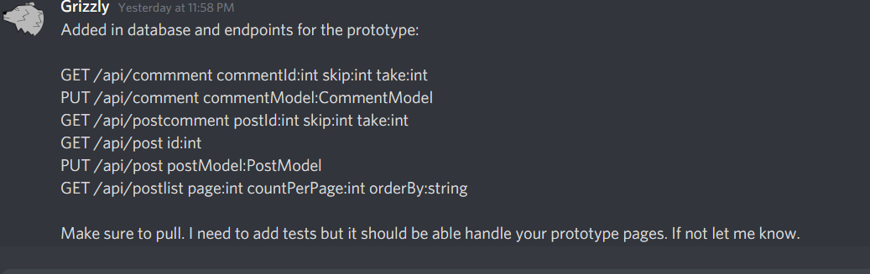

#### View comments interface

The view comments interface is a subset of the view post interface, allowing users to view comments on a given posting. The user will use this interface to read discussion trees on the posting.

https://old.reddit.com/r/gaming/comments/ls2hnd/bf_bad_company_2_is_a_masterpiece_in_simplicity/

